RasterPlus Windows Edition

Device Notes

Version 5.0
© 2004 Graphx, Inc
Contents
BITMAPPLUS 1
Minilabs 5
Agfa 6
Fuji Frontier 10
US Standard Interface 11
PIC Pro Interface 12
C4/C5 Interface 13
Generic Minilab 16
Gretag NETPRINTER and MILECA 20
Kodak DLS Minilab 23
Konica 27
Noritsu 31
MP-1600 AND QSS-2701 31
QSS-2801, QSS-2802, QSS-2901,QSS-3001, QSS-3011, QSS-3101, QSS-31PRO, QSS-32 Series, dDP Series 34
Film Recorders 38
AGFA/Matrix Color Film Rrecorders 39
CCG Color Film Recorders 41
LaserGraphics 42
MGI 44
Polaroid Digital Palette 46
Mirus 51
Montage Graphics 53
Samurai CFR 54
Sony UP-D8800/UP-D70A/POLAROID PLD8800 55
UTI/Celco 56
Printers 57
Fuji Pictrography 2000, 3000, 3500, 4000/4000II AND Pictrostat 400 58
Fuji PrintPix – NC-600D and NC-1000 60
Kodak XL 7700 AND XLT 7720 62
Kodak 8650/8670/8660 63
Mitsubishi 9000D and 9500D Series 64
Sienna/Gretag Fotoprint 65
Printer Cloaking with RasterPlus 66

BITMAPPLUS
BitMapPlus outputs raster files of any resolution and page dimensions selected by the user. The resulting files can be sent to print drivers or RIPs for large-format inkjet printers, large-format photographic printers, or large-format film recorders. All RasterPlus functions are available including Application Printing, Network Printing, Drag and Drop Printing. Files created by BitMapPlus can be used creatively in a wide variety of custom imaging configurations. It adds significant value to systems where existing printing software lacks sophisticated performance and throughput capabilities. The customer must provide customer ICC profiles that can then be enabled in BitMapPlus.

Basic setup
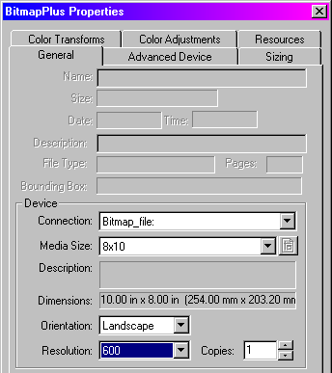
Go to BitMapPlus Properties...General, select one of the existing Media Sizes and Resolutions. A small number of default settings are available during the first use of the application following installation. Most likely, you will want to create custom sizes that will be available here.

Selection of Output file type
Go to BitMapPlus Properties...Advanced Device and select a file type from the pull-down menu. The choices include: TIFF LZW Compressed RGB, TIFF Uncompressed RGB, Targa Compressed RGB, Targa Uncompressed RGB, TIFF LZW Compressed Mono, TIFF Uncompressed Mono, Targa Compressed Mono, Targa Uncompressed Mono, JPEG RGB, and TIFF Uncompressed CMYK. When selecting JPEG, the JPEG Quality pull down is available where compression values ranging from 0 to 10 can be selected. Value 6 is the default.

Select an option for Output Filename: source name prefix, Prompt for name, or Unique filename. Enter a destination for the file that will be created by BitMapPlus on a local or network location.

Setting custom resolution and page size
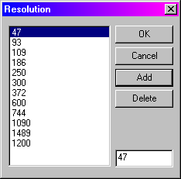
In BitMapPlus Properties...Advanced Device click Custom Res. This launches a Resolution dialog box that displays the resolutions that are currently available. Enter a new value in the blank field and click Add to add it to the list.

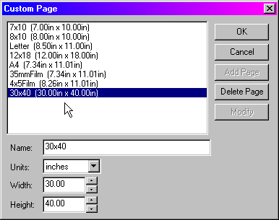
Similarly, click Custom Page that opens a dialog box showing the available page sizes. In the boxes below enter a Name, Width, and Height of a new page. Click Add Page, Delete Page, or Modify as necessary.
Package Printing with BitMapPlus

BitMapPlus supports Graphx PackagePlus, a separate application for making custom photo packages with image overlays.

Minilabs

Agfa
RasterPlus supports the Agfa d-lab.1, d-lab.2, d-lab.3, MSC.d with FIT minilabs.

Note: The d-Workflow must be installed and accessible from the PC where RasterPlus is installed.

Installation
- Open RasterPlus. Create a queue for the appropriate device.
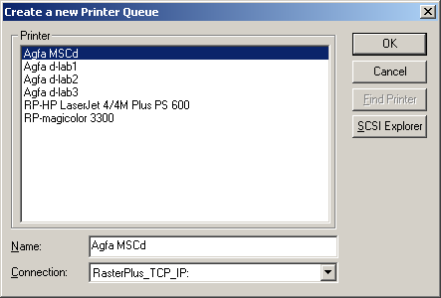

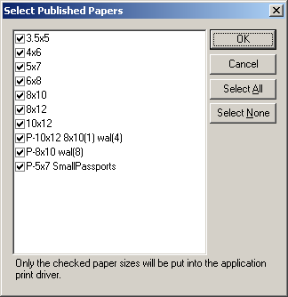
- Select the paper sizes that should be available to the print driver.

- Click OK.
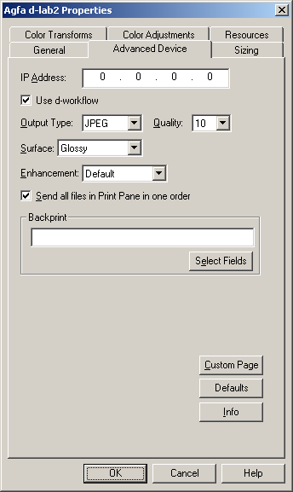
- The driver is now installed.
- After the driver has been installed additional device properties can be set. Select Edit Default Queue Properties Advanced Device.
- Enter the IP Address of the Agfa d-Workflow PC.
- Select Use d-workflow. This requires Agfa release 7.50P or greater. All previous releases should uncheck this box.
- Select the Output Type and Quality.
Note: TIFF is only available for the dlab.3.
- Select the Surface.
Note: Matte is only available for the MSC.
- Select or deselect Send all Files in Print Pane as one order.
- Define the Backprint information.
- Click OK

Making a Custom Page Size

RasterPlus comes with a selection of page or paper sizes but you may wish to create a custom page size for a special application or assign an existing page size to a paper defined for the current device.

To make a custom page size:
- Select Edit Default Queue Properties Advanced Device.
- Click the Custom Page button, which opens the following dialog box. This dialog box displays the current page sizes and the associated definition.

To modify an existing page:
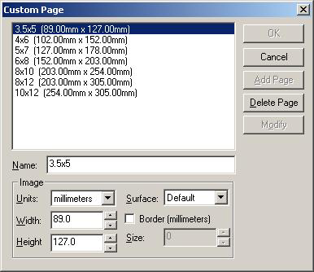
- Select the page to be modified. Change the image information as desired.
- Click on the Modify button.

To add a new page:
- Enter a new name in the Name field.
- Enter the desired Image information.
- Units - Specifies how Width/Height will be defined
- Width - Specifies the Media Width
- Height - Specifies the Media Height
- Surface - Surface type to be used for this media
  - Default - Default to the surface defined in RasterPlus Advanced device
  - Undefined - Special 'Other' surface
  - Any - Use whatever is on the printer
- Border - Define the border size to create a 'Bordered Print'
Note: Border must be checked AND a size greater than zero specified for this option to work.
- Click on the Add button.
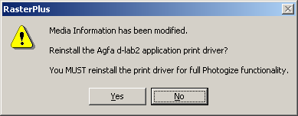
- Click the OK button.
- Click the OK button on the Advanced Devices dialog.
- A message box is displayed. Click Yes.
This will update the media based on the changes made in the Advanced Device dialog box. This will display the Select Published Papers dialog. Select or deselect the media sizes that will be available when File Printing.
- The driver is now ready to print.

Fuji Frontier
RasterPlus supports the Frontier 330, Frontier 350, Frontier 370, and Frontier 390 with this driver.

Installation
- Open RasterPlus. Create a queue for the appropriate device.
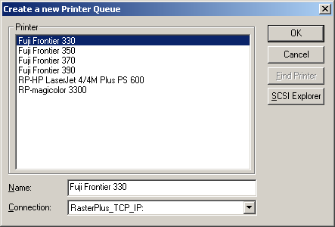

- Select the paper sizes that should be available to the print driver.
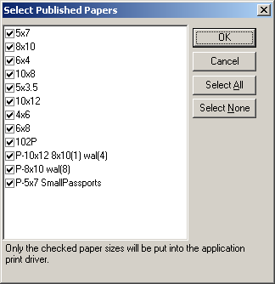
NOTE: The Name defined in RasterPlus MUST be exactly the same as the paper sizes defined in the Frontier Print Size setup. These paper sizes ARE case sensitive.

- Select Edit...Default Queue Properties...Advanced Device.
- Select the appropriate Interface.
  - US Standard
  - PIC Pro
  - C4/C5

US Standard Interface
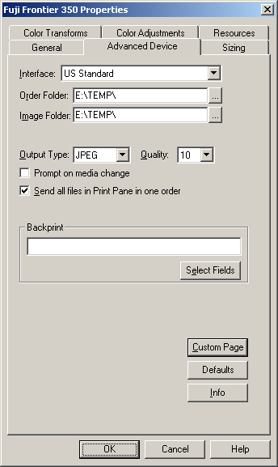
- Click the button to the right of the Order Folder: path field. This opens a dialog box called Select Directory.
NOTE: Version 2.0 or greater should point to the "PrintRequest" folder.
Versions prior to 2.0 MUST point to the "DIManager\RemoteOrder" directory.

- Click the button to the right of the Image Folder: path field. This opens a dialog box called Select Directory. The images can be placed anywhere as long as the location is a valid UNC path accessible by the Frontier PC.
- Select or deselect the `Prompt on media change' When `Prompt on media change' is selected RasterPlus will pause processing and prompt the operator to verify the Frontier media.
- Select the Output Type and Quality.
- Select or deselect Send all files in Print Pane as one order.
- Define the Backprint text.
- Click OK.
- The driver is now ready to print.

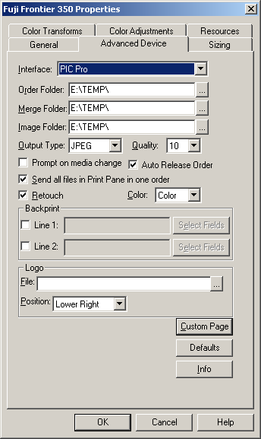
PIC Pro Interface

- Click the button to the right of the Order Folder: path field. This opens a dialog box called Select Directory. This folder must be the Order Data folder on the PicPro Labserver.
- Click the button to the right of the Merge Folder: path field. This opens a dialog box called Select Directory. This folder must be the Merge Data folder on the PicPro Labserver.
- Click the button to the right of the Image Folder: path field. This opens a dialog box called Select Directory. This folder must be the DIGIN folder on the PicPro Labserver.
- Select the Output Type and Quality.
- Select or deselect the “Prompt on media change”. When “Prompt on media change” is selected RasterPlus will pause processing and prompt the operator to verify the Frontier media.
- Select or deselect “Auto Release Order”. If “Auto Release Order” is not selected an operator will have to manually release the order on the PicPro.
- Select or deselect Send all files in Print Pane as one order.
- Select or deselect Retouch
- Select the appropriate Color option
- Define the Backprint text.
- Specify the Logo File. . .if required.
- Select the position of the Logo File
- Click OK.
- The driver is now ready to print.
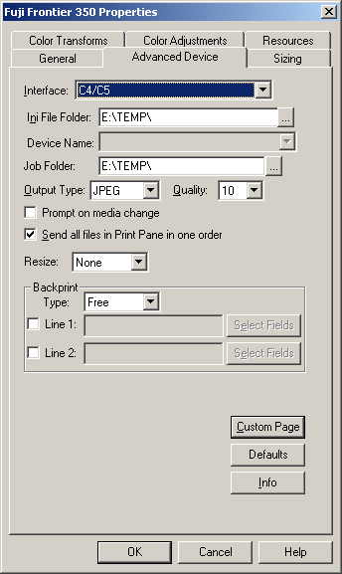

C4/C5 Interface
- Specify the folder the contains the FdiaDevice.ini file. The device names will be extracted from this file and placed in the Device Name field.
- Select the device in the Device Name field.
- Click the button to the right of the Job Folder.
  - This opens a dialog box called Select Directory.
  - This folder should be the Frontier Job Folder.
- Select the Output Type and Quality.
- Select Resize option
- Select or deselect the `Prompt on media change'. When `Prompt on media change' is selected RasterPlus will pause processing and prompt the operator to verify the Frontier media.
- Select or deselect Send all files in Print Pane as one order.
- Select the backprint Type.
- Define the Backprint text.
- Click OK.
- The driver is now ready to print.

Making a Custom Page Size
RasterPlus comes with a selection of page or paper sizes but you may wish to create a custom page size for a special application or assign an existing page size to a paper defined for the current device.

To make a custom page size:
- Select Edit...Default Queue Properties...Advanced Device.
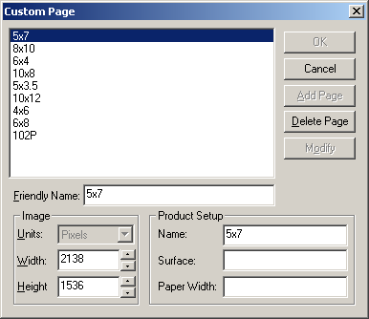
- Click the Custom Page button, which opens the following dialog box. This dialog box displays the current page sizes and the associated definition.

Note: Pixels is the only valid definition for an image size. This information is used by the Frontier to determine a valid image size and MUST match exactly the definition of the Frontier Print Size setup.

The `Friendly Name' is the identifier that will be seen by the operator.

Product Setup Information
The Name defined in the Product Setup MUST be exactly the same as the paper sizes defined in the Frontier Print Size setup. These paper sizes ARE case sensitive.

The Surface and Paper Width are used when `Prompt to change media' is check. These fields will be used in the dialog box to notify the operator which paper should be loaded on the Frontier for the job that is about to print.

To modify an existing page:
- Select the page to be modified. Change the Image information as desired.
- Click on the Modify button.

To add a new page:
- Enter a new name in the Name field.
- Define the Image information to be used for this page.
- Click on the Add button.
- Click the OK button.
- Click the OK button on the Advance Devices dialog.
- A message box is displayed. Click Yes. This will update the media based on the changes made in the Advanced Device dialog box. This will display the Select Published Papers dialog. Select or deselect the media sizes that will be available when File Printing.
- The driver is now ready to print.

Generic Minilab

Installation
- Open RasterPlus. Create a queue for the appropriate device.
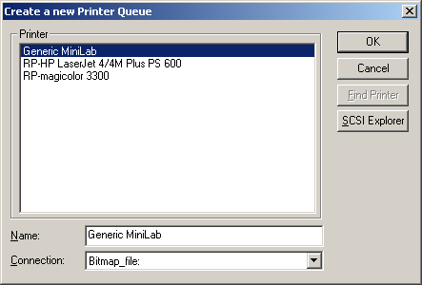

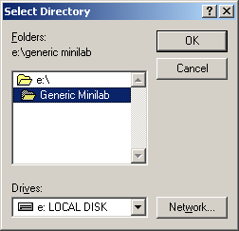
- Select Edit...Default Queue Properties...Advanced Device. Click the button to the right of the Destination: path field. This opens a dialog box called Select Directory.

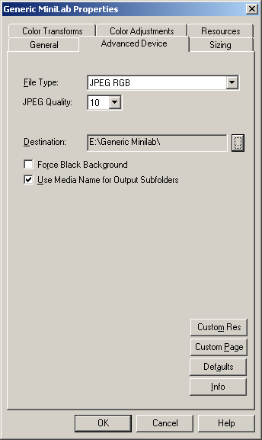
- Select the Output Type and Quality.
- Select or deselect Force Black Background.
- Select or deselect Use Media name for Output Subfolders.
- Click OK.
- The driver is now ready to print.

Making a Custom Page Size
RasterPlus comes with a selection of page or paper sizes but you may wish to create a custom page size for a special application or assign an existing page size to a paper defined for the current device.

- To make a custom page size, select Edit...Default Queue Properties...Advanced Device.
- Click the Custom Page button, which opens the following dialog box. This dialog box displays the current page sizes and the associated definition.
- Modify an existing page.
  - Select the page to be modified. Change the Image information as desired.
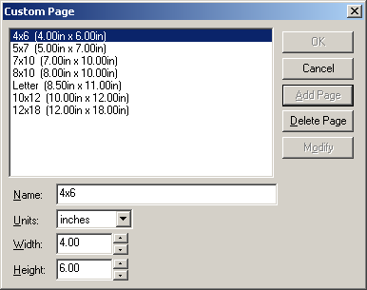
  - Click on the Modify button.
- Add a new page.
  - Enter a new name in the Name field.
  - Define the Image and Paper to be used for this page.
  - Click on the Add Button.
- Click OK.
- Click OK on the Advance Devices dialog.
- A message box is displayed. Click Yes. This will update the media based on the changes made in the Advanced Device dialog box. This will display the Select Published Papers dialog. Select or deselect the media sizes that will be available when File Printing.
- The driver is now ready to print.

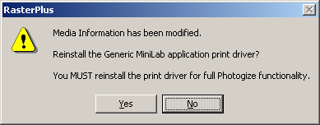

Making a Custom Resolution
RasterPlus comes with a selection of resolution but you may wish to create a different resolution for a special application.

- To make a custom page size, select Edit...Default Queue Properties...Advanced Device.
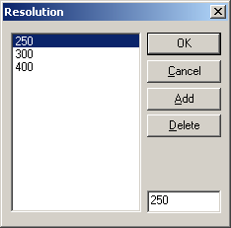
- Click the Custom Resolution button, which opens the following dialog box. This dialog box displays the current resolution.
- Enter the resolution that is to be added.
- Click the Add button.
- Click OK.
- Click the OK button on the Advance Devices dialog.
- A message box is displayed. Click Yes. This will update the media based on the changes made in the Advanced Device dialog box. This will display the Select Published Papers dialog. Select or deselect the media sizes that will be available when File Printing.
- The driver is now ready to print to use the new resolution.

Gretag NETPRINTER and MILECA
RasterPlus supports the Gretag Netprinter 812, Netprinter Digital Station and printers via a network connection for file transfer.

Installation
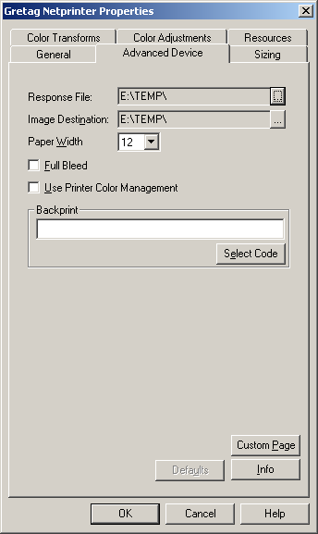
Consult the CREW manual before installing RasterPlus.

- Before opening RasterPlus, select the directory on the network that is defined in the CREW client that will accept the "Response File" and map this to a drive.
- Map another drive to folder to the CREW Hotfolder that is being monitored by the Netprinter. This hotfolder must be accessible to both RasterPlus and CREW. See the CREW manual or your Gretag installer.
- Open RasterPlus. Select Edit...Default Queue Properties...Advanced Device.

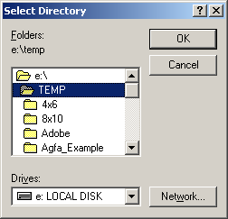
- Click the button to the right of the Response File path field. This opens a dialog box called Select Directory. Select the mapped drive you set up in Step 1, then click OK. Likewise, the Image Destination must point to the drive you mapped in Step 2.
- Select or deselect Full Bleed.
- Select or deselect Printer Color Management. If you select this option do not use ICC profiles, which are selected under the Color Transforms tab. You may be applying color correction twice.

Making a Custom Page Size
RasterPlus comes with a large selection of standard page or paper sizes but you may wish to create custom page size for a special application.

- To make a custom page size, select Edit...Default Queue Properties...Advanced Device.
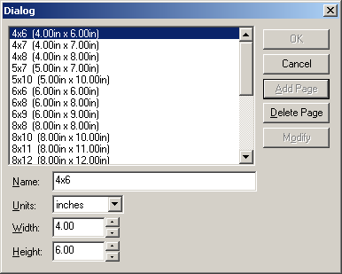
- Click the Custom Page button that opens a dialog box where you will also see the available page sizes. Enter a name for the new custom page that includes the desired dimensions. Enter the width and height. Click the Add Page button. You can also delete page sizes or modify existing ones here. The new page size will now be available in Edit...Default Queue Properties...General...Media Size.

Custom Packages and Overlays
RasterPlus comes with a variety of standard photo package configurations that are selectable in Edit...Default Queue Properties...General...Media Size. When customers require non-standard image sizes within a Package, or you wish to create custom graphical overlays for packages, use PackagePlus; an optional Graphx program that integrates with the Gretag Netprinter/ Mileca version of RasterPlus. For more information, refer to the chapter on Digital Package Printing.

Setting Resolution
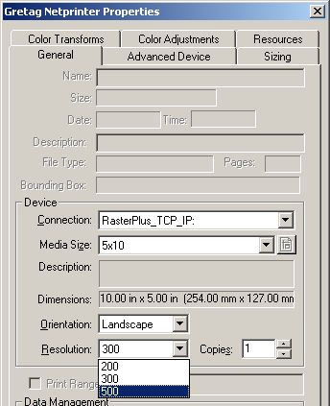
To change the output resolution you must change the setting on the Netprinter and in RasterPlus. Select Edit... Default Queue Properties...General. In the Resolution pulldown select the resolution that matches the setting on the Netprinter.

Kodak DLS Minilab
RasterPlus Plus supports the Kodak 2711 DLS, Kodak 2721 DLS, Gretag digital DLS, Phogenix DFX, System 88 DLS, System 89 DLS, and Noritsu 2921 DLS, Noritsu 3011 DLS devices.

RasterPlus supports the above drivers with the following systems requirements:

- The System Management Software for Kodak DLS Minilab should be Version 1.1A with Mod 2.

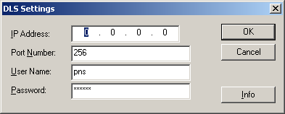
Connection to the DLS
RasterPlus communicates with the Kodak DLS Minilab host computer via TCP/IP. Contact your IT manager or Kodak/Noritsu installer for the Network settings for IP Address, Port Number, User Name, and Password.

Connect the RasterPlus host computer into the same network as the Kodak DLS. (10/100baseT TCP/IP network). These settings may also be applied in Queue Properties...Advanced Device.
Output Type may also be selected.

This dialog box is presented by RasterPlus upon initial installation, or reinstallation of the Kodak DLS driver.

Output type - image quality setting
In Kodak DLS Minilab Properties...Advanced Device, the default setting is JPEG, Quality 6, similar to file type settings in Adobe Photoshop. Quality 6 creates a file with a medium level of compression and almost no noticeable loss in image quality. Likewise a setting of Quality 10 provides almost no compression, while Quality 1 makes the smallest file but sacrifices image quality. Experienced operators who seek to maximize file transfer speeds for optimal performance should adjust these settings. The other output file type is TIFF, which makes a loss less file without compression and provides the highest quality image.

Options for Customer Order Files
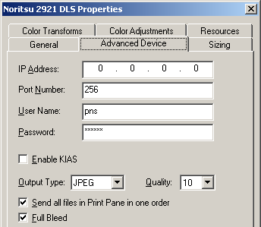
The checkbox Send all files in Print Pane in one order addresses how COS files (Customer Order files) are sent to the printer. When checked, all files in the RasterPlus Print pane will be sent as one order. Up to 40 files may be sent simultaneously. Files beyond the quantity 40 cutoff will be compiled in the next order that processes immediately after. When unchecked, files are sent as individual orders.

Full Bleed
An image that bleeds beyond the page boundaries enables an automatic print or paper cutter to produce a print with an image that comes precisely to the paper edge. The following parameters are applied when Full Bleed is checked:
- If the print is < 6 inches, the bleed = 1 millimeter.
- If the print is > 6 inches and < 2 inches, the bleed = 1.5 millimeter.
- If the print is > 12 inches, the bleed = 2.0 millimeter.
Package Printing from a Macintosh
Package printing options are available to Windows and Macintosh clients on a network when the Kodak DLS printer driver is set up as a shared network resource. On Windows, a comprehensive range of paper sizes and packages is available. However, limitations of the Macintosh OS restrict the availability of all the packages. Only one package for each standard paper size can be seen from a Mac.

Making a Custom Page Size
RasterPlus comes with a large selection of standard page or paper sizes but you may wish to create custom page size for a special application.

- To make a custom page size, select Edit...Default Queue Properties...Advanced Device.
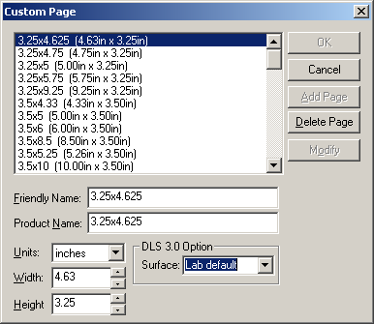
- Click the Custom Page button that opens a dialog box where you will also see the available page sizes. Enter a name for the new custom page that includes the desired dimensions. Enter the width and height. Click the Add Page button. You can also delete page sizes or modify existing ones here. The new page size will now be available in Edit...Default Queue Properties...General...Media Size.

Special Notes:
- The ‘Product Name’ must match a product defined in the DLS. If this ‘Product Name’ dose not match a DLS product the image will NOT print.
- The surfaces define here are mapped to the DLS Paper Surface as follows:
  - Paper Surface 1:
    - Lab Default,
    - Glossy
    - High Glossy.
  - Paper Surface 2:
    - Smooth Lustre
    - Ultra Smooth Hi Lustre
    - Fine Grained Lustre
    - Lustre.
  - Paper Surface 3:
    - Semi Matte
  - Paper Surface 4:
    - Matte
    - Deep Matte.
  - Paper Surface Set to DLS Default Value
    - Other
    - Silk
    - Laminate

Konica
RasterPlus supports the QD-21, QD-21 Plus, R1 devices with this driver.

Installation
- Open RasterPlus. Create a queue for the appropriate device.
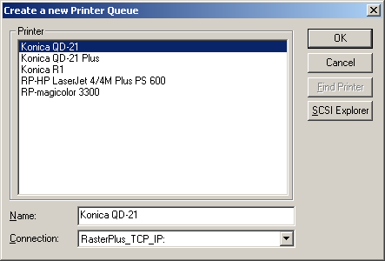
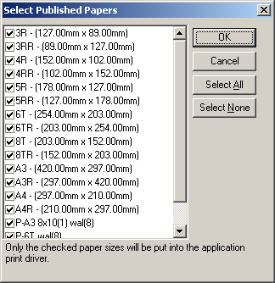
- Select the paper sizes that should be available to the print driver.

- Select Edit...Default Queue Properties...Advanced Device.
Click the button to the right of the Data Folder: path field. This opens a dialog box called Select Directory. This field MUST point to the `QDPRINT' directory. See the printer installation manual or contact your Konica installer for detailed information.
- Select the Output Type and Quality.
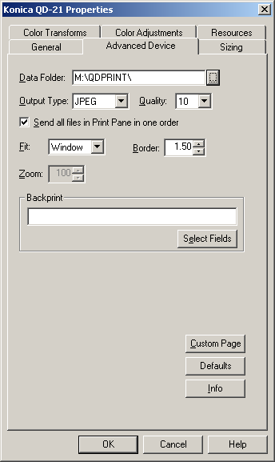
- Select or deselect Send all files in Print Pane as one order.
- Select the Fit, Border, and Zoom options.
- Define the Backprint text.
- Click OK.
- The driver is now ready to print.

Making a Custom Page Size
RasterPlus comes with a selection of page or paper sizes but you may wish to create a custom page size for a special application or assign an existing page size to a paper defined for the current device.

To make a custom page size:
- Select Edit...Default Queue Properties...Advanced Device.
- Click the Custom Page button, which opens the following dialog box. This dialog box displays the current page sizes and the associated definition.

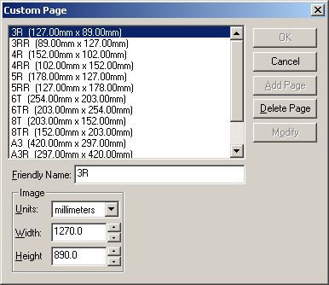

To modify an existing page:
- Select the page to be modified. Change the Image information as desired.
- Click on the Modify button.

To add a new page:
- Enter a new name in the Name field.
- Define the Image to be used for this page.
- Click on the Add button.
- Click the OK button.
- Click the OK button on the Advance Devices dialog.
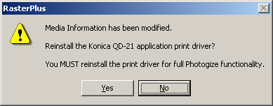
- A message box is displayed. Click Yes. This will update the media based on the changes made in the Advanced Device dialog box. This will display the Select Published Papers dialog. Select or deselect the media sizes that will be available when File Printing.
- The driver is now ready to print.

Noritsu
RasterPlus supports the MP-1600, QSS-2701, QSS-2801, QSS-2802, QSS-2901, QSS-3001, QSS-3011, QSS-3101, QSS-31PRO, QSS 32 Series, QSS 33 Series and dDP Series Noritsu devices.

MP-1600 AND QSS-2701
RasterPlus supports the above devices with the following requirements:

- EZ-Mall must be installed on the MP-1600 or QSS-2701 printer.
- RasterPlus must have access to the printer's PC through the network.

Installation
- Create the network directory that will be used for the EZ-Mall Hotfolder interface.
- Set up the EZ-Mall Hotfolder interface.
- Create a mapped network drive pointing to the directory created in Step 1.
- Create a mapped network drive pointing to the ProgramFiles directory on the device PC. This will be used in a later step.
- Open RasterPlus. Create a queue for the appropriate device.
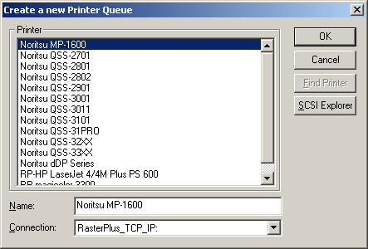
- Select the paper sizes that should be available to the print driver.
NOTE: This is best done after step 9. The initial values are default values that have not yet been associated with channels.
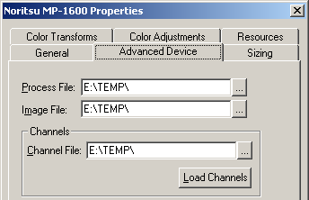
- Select Edit...Default Queue Properties...Advanced Device. Click the button to the right of the Process File: path field. The opens a dialog box called Select Directory. Select the mapped drive created in step 3, and then click OK. Likewise the Image File must point to the drive that you mapped in step 3.
- Click the button to the right of the Channel File: path field. The opens a dialog box called Select Directory. Select the location that contains the Channel Information File on your Minilab System. This should be located in the folder Program Files\NKC\Data.
- Click Load Channels button. This will display a message box that indicates the number of channels found in the channel file. If load channels fails an error message box will be displayed. Correct the error and retry. Select the Output Type and Quality.
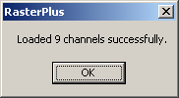

- Select or deselect Send all files in Print Pane as one order
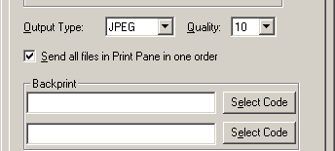
- Define the Backprint text.
- Click OK.

- A message box is displayed. Click Yes. This will update the media based on the changes made in the Advanced Device dialog box. This will display the Select Published Papers dialog. Select or deselect the media sizes that will be available when File Printing.

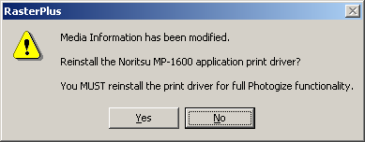
- The driver is now ready to print.

QSS-2801, QSS-2802, QSS-2901,QSS-3001, QSS-3011, QSS-3101, QSS-31PRO, QSS-32 Series, QSS-33 Series, dDP Series

RasterPlus supports the above devices with the following requirements:

- Net Order software must be installed on the device.

Connection to QSS Minilabs
RasterPlus communicates with the Net Order software via TCP/IP. Contact your IT manager of Noritsu installer for the network settings for IP Address.

Connect the RasterPlus host computer into the same network as the Net Order PC.

Installation
- Open RasterPlus. Create a queue for the appropriate device.
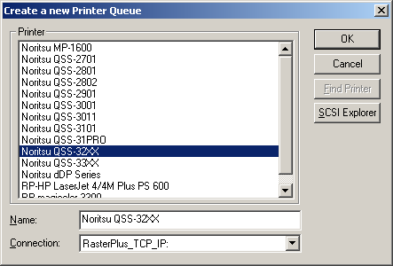
- Select the paper sizes that should be available to the print driver.
NOTE: This is best done after creating the Custom Page sizes after the machine Paper Width and Advance are assigned.
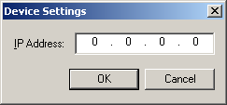
- Enter the TCP/IP address provide by your IT Manager or Noritsu installer.
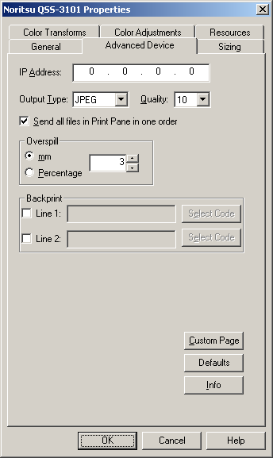
- Select Edit...Default Queue Properties...Advanced Device.
- Select the Output Type and Quality.
- Select or deselect Send all files in Print Pane as one order.
- Select Overspill type and value as required.
- Define the Backprint text.
- Click OK.
- The driver is now ready to print.

Making a Custom Page Size
RasterPlus comes with a selection of page or paper sizes but you may wish to create a custom page size for a special application or assign an existing page size to a paper defined for the current device.

- To make a custom page size, select Edit...Default Queue Properties...Advanced Device.
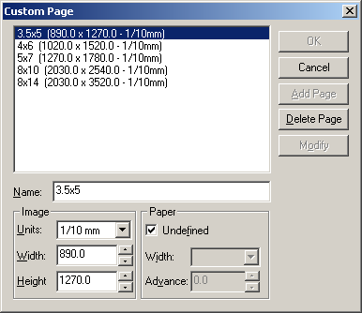
- Click the Custom Page button, which opens the following dialog box. This dialog box displays the current page sizes and the associated definition.
- Modify an existing page.
  - Select the page to be modified. Change the Image or Paper information as desired.
    - Selecting Undefined paper causes RasterPlus to search for a registered paper size, at print time, that will allow the image to print.
    - A defined paper size, Width and Advance, causes RasterPlus to print the image to the specified Paper.
  - Click on the Modify button.

- Add a new page.
  - Enter a new name in the Name field.
  - Define the Image and Paper to be used for this page.
  - Click on the Add Button.
- Click the OK button.
- Click the OK button on the Advance Devices dialog.
- A message box is displayed. Click Yes. This will update the media based on the changes made in the Advanced Device dialog box. This will display the Select Published Papers dialog. Select or deselect the media sizes that will be available when File Printing.
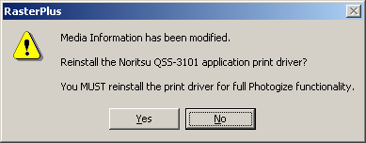
- The driver is now ready to print.

Film Recorders

AGFA/Matrix Color Film Rrecorders
RasterPlus supports most Agfa film recorders via GPIB or SCSI interface.

Model | 95-GPIB | 95- SCSI | NT-GPIB | NT-SCSI
Matrix QCR-D/Z | Yes | No | Yes | No
Matrix PCR | Yes | No | Yes | No
Agfa PCR II/Plus | Yes | Yes | Yes | Yes
Agfa ProColor | Yes | Yes | Yes | Yes
Agfa Alto | Yes | Yes | Yes | Yes
Agfa Forte | Yes | Yes | Yes | Yes
Agfa FotoColor | Yes | Yes | Yes | Yes
Agfa FotoPro | Yes | Yes | Yes | Yes

SCSI Printing
To properly install an Agfa/Matrix Color Film Recorder as a SCSI Device under Windows, refer to the Connecting Your Device chapter in this manual.

GPIB Printing
To properly install an Agfa/Matrix Color Film Recorder using GPIB under Windows, refer to the Connecting Your Device chapter in this manual.

Agfa PPD Files
RasterPlus has PostScript Printer Description (PPD) files that describe the features of all the supported printers. These PPD files may be needed by some applications like PageMaker and when configuring to print from a network node. The PPD files are created when the printer is installed under Windows and placed in the RasterPlus\CrossPlatform directory.

pcr.ppd Agfa PCR
pcrii.ppd Agfa PCR II/PCR II Plus
qcr.ppd Agfa QCR
forte.ppd Agfa Forte
procolor.ppd Agfa ProColor
alto.ppd Agfa Alto
fotocolor.ppd Agfa Fotocolor
proslide.ppd Agfa ProSlide

CCG Color Film Recorders
RasterPlus supports most CCG film recorders via GPIB or SCSI interface.

Model | 95-GPIB | 95-SCSI | NT-GPIB | NT-SCSI
CCG PCR P | Yes | Yes | Yes | Yes
CCG PCR 4 | Yes | Yes | Yes | Yes
CCG PCR 8 | Yes | Yes | Yes | Yes
CCG PCR 16 | Yes | Yes | Yes | Yes

SCSI Printing
To properly install a CCG Color Film Recorder as a SCSI Device under Windows, refer to the Connecting Your Device chapter in this manual.

GPIB Printing
To properly install a CCG Color Film Recorder using GPIB under Windows, refer to the Connecting Your Device chapter in this manual.

CCG PPD Files
RasterPlus has PostScript Printer Description (PPD) files that describe the features of all the supported printers. These PPD files may be needed by some applications like PageMaker and when configuring to print from a network node. The PPD files are created when the printer is installed under Windows and placed in the RasterPlus\CrossPlatform directory.

CCG PCR P | Pcrp.ppd
CCG PCR 4 | Pcr4.ppd
CCG PCR 8 | Pcr8.ppd
CCG PCR 16 | Pcr16.ppd

LaserGraphics
RasterPlus supports the following Lasergraphics film recorders in Windows 95/98 and Windows NT 4.0 via SCSI:

Personal LFR Plus
Personal LFR
Personal LFR X
Personal LFR X-95
Personal LFR PRO
Mark II
Mark II DPM
Mark III
Mark III DPM
Mark V DPM
Mark VI DPM

SCSI Printing
To properly install the Lasergraphics film recorder as a SCSI Device under Windows, refer to the SCSI Devices chapter in this manual.

Film Tuning
To create new films using a base film and the color adjustments:

- Select your base film in the Options dialog.
- Adjust the colors.
- Click Save Film.
- Name the film.

The new film will be created and selected in the Combo box. The red, green and blue color adjustments will reset as if this were a new base film. Any further color adjustments will multiply the originals. For example, if you create Elite II NEW with Elite II as the base with red = 120, it will show up with red = 100. If you select red = 110 with Elite II NEW, it will actually be Elite II with red = (120 * 110 / 100). The values are naturally clamped to 25 and 400.

You can also delete a new film by selecting the film in the Combo box and clicking "Delete Film". Base films cannot be deleted.

Important Note on Film Tuning!
The print drivers installed by RasterPlus in Windows will include these new films if they exist at the time of print driver installation. If you add or delete custom films, you should remove the print driver from the Windows printer control panel and re-install it so the new film tables will appear.

Lasergraphics PPD Files
RasterPlus has PostScript Printer Description (PPD) files that describe the features of all the supported printers. These PPD files may be needed by some applications like PageMaker and when configuring to print from a network node. The PPD files are created when the printer is installed under Windows and placed in the RasterPlus\CrossPlatform directory.

persplus.ppd Personal LFR Plus
perslfr.ppd Personal LFR
lfrx.ppd Personal LFR X
lfrx95.pps PersonalLFR X-95
mark2.ppd Mark II
mark2dpm.ppd Mark II DPM
mark3.ppd Mark III
mark3dpm. Mark III DPM
mark5dpm.ppd Mark V DPM
mark6dpm.ppd Mark VI DPM

MGI
RasterPlus supports most MGI film recorders via GPIB or SCSI interface.

Model | 95-GPIB | 95-SCSI | NT-GPIB | NT-SCSI
MGI Solitaire 4/8/16 | Yes | No | Yes | No
MGI Solitaire 16xps | Yes | Yes | Yes | Yes
MGI Gemini | Yes | Yes | Yes | Yes
MGI Cine II/III | Yes | Yes | Yes | Yes
MGI Sapphire | Yes | No | Yes | No
MGI Sapphire Pro | Yes | Yes | Yes | Yes
MGI Opal | Yes | Yes | Yes | Yes
MGI Opal Plus | Yes | Yes | Yes | Yes
MGI Solitaire 8xp | Yes | Yes | Yes | Yes

SCSI Printing
To properly install an MGI Color Film Recorder as a SCSI Device under Windows, refer to the Connecting Your Device chapter in this manual.

This version of RasterPlus supports most MGI cameras via a SCSI interface board. Because of limitations inherent in the Windows SCSI system, the following film recorders are NOT supported via SCSI: MGI Sapphire, MGI Solitaire 4, 8, and 16.

If you are using SCSI with an MGI film recorder, you must use the Ctrl-A configuration feature of the BIOS SCSI manager during boot-up to set the Initiate Sync Negotiation feature to No and set data transfer rate to it's lowest setting for the SCSI ID which is being used by the film recorder

GPIB Printing
To properly install an MGI Color Film Recorder using GPIB under Windows, refer to the Connecting Your Device chapter in this manual.

MGI PPD Files
RasterPlus has PostScript Printer Description (PPD) files that describe the features of all the supported printers. These PPD files may be needed by some applications like PageMaker and when configuring to print from a network node. The PPD files are created when the printer is installed under Windows and placed in the RasterPlus\CrossPlatform directory.

MGI Opal | opal.ppd
MGI Opal Plus | opalplus.ppd
MGI Solitaire 4 | sol4.ppd
MGI Solitaire 8 | sol8.ppd
MGI Solitaire 16 | sol16.ppd
MGI Solitaire 8xp | sol8xp.ppd
MGI Solitaire 16 xps | sol16xps.ppd
MGI Sapphire | sapphire.ppd
MGI Sapphire Pro | sapppro.ppd
MGI Gemini | gemini.ppd
MGI Cine II/III | cine.ppd

Polaroid Digital Palette
RasterPlus supports the following Polaroid Palette film printers:

Device | Win 95 Interface | WIN NT Interface
CI-3000 | Centronics | Not Supported
CI-3000S | Centronics | Not Supported
CI-5000 S | Centronics and SCSI | SCSI Only
HR 6000 | Centronics and SCSI | SCSI Only
ProPalette 7K Series | Centronics and SCSI | SCSI Only
ProPalette 8K Series | Centronics and SCSI | SCSI Only

LPT Centronics Printing
The LPT port mode should be set to ECP in the BIOS Setup of the computer.

SCSI Printing
To properly install the Polaroid Digital Palette as a SCSI Device under Windows, refer to the SCSI Devices chapter in this manual.

Device Options
When you click Advanced Device from the Queue Properties Job window of RasterPlus, you get the following dialog:

The meaning of these items:

Film Type .............................. Select the type of film you've loaded in the camera; a description of the film will be displayed in the edit box below.

Brightness Calibration .......... Specify what to do when the camera reports a calibration error; only change this on the advice of a Polaroid technician (not available on the ProPalette 8000 and 7000).

Data Delivery ........................ Specify the way that data is sent to the color film recorder; only change this on the advice of a Polaroid technician (not available on the ProPalette 8000 and 7000).

Data Quality ......................... Fast is the default and will result in faster imaging. Fine will result in slower, marginally-higher quality imaging. (not available on the ProPalette 8000 and 7000).

Force black background ....... Fill all non-object areas of the image with black. This is especially useful when imaging 35mm slides where the default white back ground may cause unsightly lines at the edges of the slide.

Single Image Mode...............If checked, will only allow one image in the buffer at a time.
SCSI Adapter # ..................... Defaults to 0. Refers to the physical number of the board the device is connected to. Click Tools...SCSI Explorer for connection information.

Exposure ............................... Set exposure levels on the camera (see below).

Cam Adjust ............................Alter the camera adjust values of the current camera back (see below).

Defaults ................................. Reset all items to their defaults.

Info ........................................ Display a dialog box that displays information about your film printer.

Setting Exposure Levels
When you click the Exposure button in the Options dialog, you get the following dialog: You can move the sliders in the above dialog to change the overall or relative color levels of the images you produce on the Digital Palette.

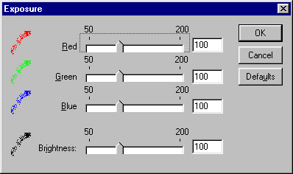

Calibrating your camera
When you click the Cam Adjust button in the Options dialog, you get the following camera adjust dialog:

You use this dialog in the following way to calibrate your camera:

- Add one of the following calibration files to your active queue based on your current camera back.

The files are located in the "Polaroid Calibration" subdirectory of your RasterPlus installation directory.

CA_35MM.CPS for 35mm camera back
CA_AUTO.CPS for Auto camera back
CA_4X5.CPS for 4x5 camera back
CA_PACK.CPS for Pack camera back
CA_6x7.CPS for 6x7 camera back
CA_6x8.CPS for 6x8 camera back

- Click Edit...Default Queue Properties...Advanced Device...Cam Adjust from the main menu of RasterPlus and check the Override for test image box. Keep clicking OK to close all the config dialogs.

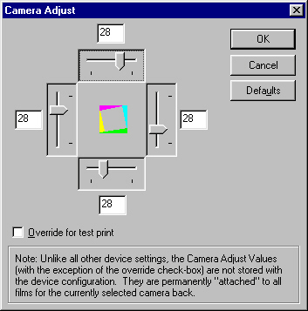

- Print the file to the Palette film printer. A calibration wedge picture will be imaged. Consult your Digital Palette manual for more information on reading the wedge values in the image.

- Click Edit...Default Queue Properties...Advanced Device...Cam Adjust from the main menu of RasterPlus and un-check the Override for test image box. Now enter the wedge values that you got from step 3. Keep clicking OK to close all the config dialogs.

Contact Polaroid technical support for help with this feature.

Polaroid PPD Files
RasterPlus has PostScript Printer Description (PPD) files that describe the features of all the supported printers. These PPD files may be needed by some applications like PageMaker and when configuring to print from a network node. The PPD files are created when the printer is installed under Windows and placed in the RasterPlus\CrossPlatform directory.

ci-3000.ppd Digital Palette CI-3000
ci-3000s.ppd Digital Palette CI-3000s
ci-5000.ppd Digital Palette CI-5000
ci-5000s.ppd Digital Palette CI-5000s
hr6000.ppd Digital Palette HR6000
p7000.ppd Pro7000K Series
p8000.ppd Pro8000K Series

Mirus
RasterPlus supports the Turbo II and Galleria filmprinters from Mirus Industries in Windows 95/98/ME and Windows NT 4.0. In Windows 95, both Centronics and SCSI are supported. In Windows NT 4.0, ONLY SCSI is supported.

SCSI Printing
To properly install the Mirus FilmPrinter as a SCSI Device under Windows, refer to the SCSI Devices chapter in this manual.

Film Tuning
To create new films using a base film and the color adjustments:

- Select your base film in the Advanced Device dialog box.
- Adjust the colors.
- Click Save Film.
- Name the film.

The new film will be created and selected in the combo box. The color adjustments will reset as if this were a new base film. Any further color adjustments will multiply the originals. For example, if you create Elite II NEW with Elite II as the base with Brightness = 120, it will show up with Brightness = 100. If you select Brightness = 110 with Elite II NEW, it will actually be Elite II with Brightness = (120*110/100). The values are naturally clamped to 50 and 200. You can also delete a new film by selecting the film in the Combo box and clicking Delete Film. Base films cannot be deleted.

Important Note on Film Tuning
The print drivers installed by RasterPlus in Global Properties will include these new films if they exist at the time of print driver installation. If you add or delete custom films, you should remove the print driver from Windows using Global Properties and reinstall it so the new film tables will appear.

Mirus PPD Files
RasterPlus has PostScript Printer Description (PPD) files that describe the features of all the supported printers. These PPD files may be needed by some applications like PageMaker and when configuring to print from a network node. The PPD files are created when the printer is installed under Windows and placed in the RasterPlus\CrossPlatform directory.

Turbo II | Turboii.ppd
Galleria | Galleria.ppd
GalleriaPro | Galpro.ppd
GalleriaPro 8 | Galprop.ppd
GalleriaPro E | Galproe.ppd

Montage Graphics
RasterPlus supports the Montage FR2 enhanced in Windows 95 and Windows NT 4.0 via SCSI.

SCSI Installation
To properly install the Montage FR2 film recorder as a SCSI device under Windows, refer to the SCSI Devices chapter in this manual.

Montage PPD Files
RasterPlus has PostScript Printer Description (PPD) files that describe the features of all the supported printers. These PPD files may be needed by some applications like PageMaker and when configuring to print from a network node. The PPD files are created when the printer is installed under Windows and placed in the RasterPlus\CrossPlatform directory.

montage.ppd Montage FR2

Samurai CFR
RasterPlus supports the Samurai CFR In Windows 95 via a Samurai I/O card.

Note that the card must be set to occupy either the memory address range E000 or C900. You should use the System control panel in Windows 95 to determine which resource is available and set the card to this address. RasterPlus will automatically find the card in your system.

Samurai PPD Files
RasterPlus has PostScript Printer Description (PPD) files that describe the features of all the supported printers. These PPD files may be needed by some applications like PageMaker and when configuring to print from a network node. The PPD files are created when the printer is installed under Windows and placed in the RasterPlus\CrossPlatform directory.

samurai.ppd Samurai CFR

Sony UP-D8800/UP-D70A/POLAROID PLD8800
RasterPlus supports the Sony UP-D8800/UP-D70A/Polaroid PLD8800 dye-sub color printer via the Windows ASPI SCSI interface.

SCSI Installation
To properly install these printers as a SCSI device under Windows, refer to the SCSI Devices chapter in this manual.

Digital Package Printing
RasterPlus Windows Edition for the Sony UP-D8800/UP-D70A/Polaroid PLD8800 supports Digital Package Printing. Please refer to the Digital Package Printing section of this manual for more details.

Sony PPD Files
RasterPlus has PostScript Printer Description (PPD) files that describe the features of all the supported printers. These PPD files may be needed by some applications like PageMaker and when configuring to print from a network node. The PPD files are created when the printer is installed under Windows and placed in the RasterPlus\CrossPlatform directory.

up-d70a.ppd UP-D70A printer
up-d8800.ppd Sony UP-D8800 printer
pld8800.ppd Polaroid PLD8800 printer

UTI/Celco
RasterPlus supports most UTI/Celco film recorders via GPIB or SCSI interface.

Model | 95-GPIB | 95-SCSI | NT-GPIB | NT-SCSI
Celco | Yes | No | Yes | No
UTI | Yes | No | Yes | No

GPIB Printing
To properly install an UTI/Celco Color Film Recorder using GPIB under Windows, refer to the Connecting Your Device chapter in this manual.

Celco/UTI PPD Files
RasterPlus has PostScript Printer Description (PPD) files that describe the features of all the supported printers. These PPD files may be needed by some applications like PageMaker and when configuring to print from a network node. The PPD files are created when the printer is installed under Windows and placed in the RasterPlus\CrossPlatform directory.

Celco eXtreme MPR/MPX | Celmpr.ppd
Celco eXtreme Nitro | Celxn.ppd
Celco Professional | Cclpro.ppd
Upgrade Technologies Phoenix | Uti.ppd

Printers

Fuji Pictrography 2000, 3000, 3500, 4000/4000II AND Pictrostat 400
RasterPlus supports the Fuji Pictrography 2000, 3000, 3500, 4000, and Pictrostat Digital 400 via the Windows ASPI SCSI interface.

SCSI Printing
Windows NT 4.0 does not have a built-in ASPI manager like the one included with Windows 95. RasterPlus will automatically run an ASPI installer at the end of its installation. To re-install the ASPI manager, run the ASPIINST.EXE program located in the \ASPI Installer folder of the RasterPlus CD. This applet will install the latest version of ASPI.

Note that RasterPlus supports the Pictrography 4000 and Pictrostat 400 in SCSI-2 mode ONLY. Be sure to set the 4000 and 400 to SCSI-2 (the default) before using it with RasterPlus.

To properly install the Fuji Pictrography as a SCSI Device under Windows, refer to the SCSI Devices chapter in this manual.

Supported Resolutions
The maximum resolution (dpi) that you can set with the Pictrography is based on the amount of memory installed in the printer:
The maximum resolution of the Pictrostat Digital 400 is 400 dpi for all page sizes except A4 Wide, 12x18 and A3 Wide which are 267 dpi.

Installed Memory Maximum Resolution
 | PG 2000,3000 | PG 4000
120MB | - - | 400dpi
48MB | 400dpi | 200dpi
30MB | 320dpi | - -
42MB | 267dpi | - -
6MB | 133dpi | - -

Digital Package Printing
RasterPlus Windows Edition for the Fuji Pictrography 2000, 3000, 3500, 4000 and Pictrostat 400 supports Digital Package Printing. Please refer to the Digital Package Printing section of this manual for more details.

Fuji PPD Files
RasterPlus has PostScript Printer Description (PPD) files that describe the features of all the supported printers. These PPD files may be needed by some applications like PageMaker and when configuring to print from a network node. The PPD files are created when the printer is installed under Windows and placed in the RasterPlus\CrossPlatform directory.

Fuji Pictrography 2000 | Fj2000.ppd
Fuji Pictrography 3000 | Fj3000.ppd
Fuji Pictrography 3500 | Fj3500.ppd
Fuji Pictrography 4000 | Fj4000.ppd
Fuji Pictrography 4000II | Fj4000II.ppd
Fuji Pictrostat 400 | Fj400.ppd

Fuji PrintPix – NC-600D and NC-1000
RasterPlus supports the Fuji NC600D via the Windows ASPI SCSI interface.

SCSI Printing
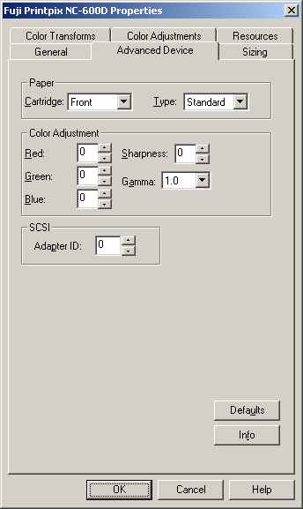
Windows NT 4.0 does not have a built-in ASPI manager like the one included with Windows 95. RasterPlus will automatically run an ASPI installer at the end of its installation. To re-install the ASPI manager, run the ASPIINST.EXE program located in the \ASPI Installer folder of the RasterPlus CD. This applet will install the latest version of ASPI Installation

- Open RasterPlus. Create a queue for the appropriate device.
- Select Edit...Default Queue Properties...Advanced Device.
- Select the Paper Cartridge.
- Select the Paper Type.
NOTE: This selection MUST match the actual cartridge and type in the NC600D or the print will fail.
- Select the Color Adjustments.
- Select the SCSI Adapter, as necessary.
- Click OK.
- The driver is now ready to print.

Kodak XL 7700 AND XLT 7720
RasterPlus supports the Kodak XL 7700 and XLT 7720 dye-sublimation printers via a GPIB interface under Windows 95 or NT 4.0.

GPIB Printing
To properly install a Kodak printer via a GPIB interface refer to the Connecting your Device chapter in this manual.

Before using RasterPlus, make sure that you have a National Instruments 488.2 GPIB board. Some older PC2, PC2A, and AT-GPIB boards are 488.1 and must be upgraded for use in Windows 95 or NT. If you have a DOS GPIB driver with a version starting in C or E, you probably have a 488.1 board; contact National Instruments (1-800-488-IEEE for further assistance).

Kodak PPD Files
RasterPlus has PostScript Printer Description (PPD) files that describe the features of all the supported printers. These PPD files may be needed by some applications like PageMaker and when configuring to print from a network node. The PPD files are created when the printer is installed under Windows and placed in the RasterPlus\CrossPlatform directory.

XL7700 | Xl7700.ppd
XLT7720 | Xlt7720.ppd

Kodak 8650/8670/8660
RasterPlus supports the Kodak 8650/8670 dye-sublimation printers via SCSI

SCSI Printing
To properly install a Kodak as a SCSI device under Windows, refer to the SCSI Devices chapter in this manual.

Kodak PPD Files
RasterPlus has PostScript Printer Description (PPD) files that describe the features of all the supported printers. These PPD files may be needed by some applications like PageMaker and when configuring to print from a network node. The PPD files are created when the printer is installed under Windows and placed in the RasterPlus\CrossPlatform directory.

Kodak 8650 | Kdk8650.ppd
Kodak 8670 | Kdk8670.ppd
Kodak 8660 | Kdk8660.ppd

Mitsubishi 9000D and 9500D Series
RasterPlus supports these Mitsubishi series printers through the USB port.
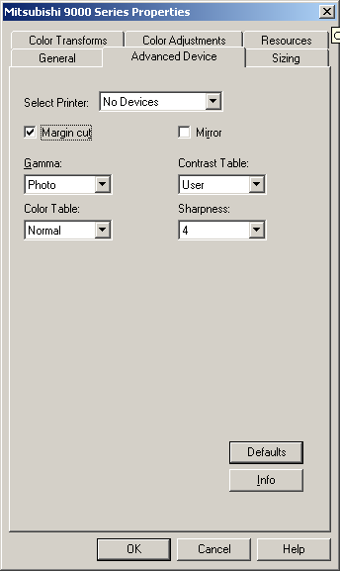
- Select Edit...Default Queue Properties...Advanced Device.
- Select the Printer.
- Check/Uncheck Margin Cut.
- Check/Uncheck Mirror. If checked this will create a ‘mirror image’ of the submitted picture
- Select the Gamma.
- Select the Color Table.
- Select the Contrast Table.
- Select the Sharpness
- Click OK.
- The driver is now ready to print

Sienna/Gretag Fotoprint
RasterPlus will interface with the FotoPrint via a standard Centronics port or FarPoint F/Port enhanced parallel controller card. Since the standard Centronics PC to FotoPrint connection is extremely slow, it is strongly recommended that you acquire and install an F/Port card. For more information on purchasing an F/Port card, please contact Sienna Imaging or FarPoint Communications.

Installing FarPoint F/Port Card Drivers
Follow the installation instructions included with your F/Port card regarding card installation. You should also run the software installer that will put drivers and utilities on your hard disk. You will need to know the interrupt (irq) and base I/O address settings of the card in order to properly run the installer. To make sure that there are no hardware conflicts, you can check the Windows 95 System settings for available irq and I/O settings. To do this:
- Select Start...Settings...Control Panel from the taskbar.
- Double click on System and click the Device Manager tab.
- Double click on Computer and look for available I/O and irq settings.

For more information on installing the FarPoint F/Port card go www.fapo.com.

Sienna PPD Files
RasterPlus has PostScript Printer Description (PPD) files that describe the features of all the supported printers. These PPD files may be needed by some applications like PageMaker and when configuring to print from a network node. The PPD files are created when the printer is installed under Windows and placed in the RasterPlus\CrossPlatform directory.

FotoPrint 500/1000 | Foto1000.ppd
FotoPrint 2000 | Foto2000.ppd
FotoPrint 3000 | Foto3000.ppd
FotoPrint 5000 | Foto5000.ppd

Printer Cloaking with RasterPlus
RasterPlus can print to any Postscript or Non-Postscript printer for which you already have installed a standard Windows Printer Driver. This driver may have come with the printer you purchased, you may have downloaded the driver from the manufacturer, or it may have been automatically installed by the Windows operating system. RasterPlus can in effect take control of, or "cloak" any printer driver such as the Epson Stylus 1270 or 1520 models. This differs from a dedicated RasterPlus driver such as the Fuji 4000II which is automatically installed by RasterPlus

What are the differences between a "True" RasterPlus driver and Printer Cloaking?

- A custom RasterPlus print driver is optimized for a specific device
- Printer Cloaking is best suited to small desktop printers.

Installation
From the menu bar select Printer...New or enter Ctrl+N. In the Window Create a new Printer Queue find the name of the printer you wish to install with the prefix "RP." Several printers may be listed.
Click on that printer name and click OK. You may see a message: Gathering Printer Information. Enter Ctrl+Q or click the Queue Properties button on the menu bar, select the Advanced Properties tab, then the Configure button. You will now have access to controls that are specific to the printer such as paper source, paper quality, and layout functions.

Basic setup is complete. Print to the new driver directly from an application such as Quark or Photoshop, drag and drop files directly into the Hold or Print Queues or a Hotfolder, or Network Print - all the standard RasterPlus functions.

The material in this document is for information only and is subject to change without notice. While reasonable efforts have been made in the preparation of this document to assure its accuracy, Graphx, Inc. assumes no liability resulting from errors or omissions in this document, or from the use of the information contained herein. No part of this manual may be reproduced or transmitted in any form or by any means, electronic or mechanical, including photocopying and recording, for any purpose without the express written permission of Graphx.

Graphx reserves the right to make changes in the product design without reservation and without notification to its users. RasterPlus®, Photogize®, and Graphx® are registered trademarks and MacFilmTM, VisualTransformTM, SmartFitTM and SmartCropTM are trademarks of Graphx, Inc. All other trademarks are the property of their respective owners.

RasterPlus uses the JAWS PostScript Level 3 Interpreter.

© Copyright 2004 Graphx, Inc., all rights reserved.

Graphx, Inc.
400 West Cummings Park
Woburn, MA 01801
Tel. 781.932.0430
Fax. 781.932.0855
www.photogize.com
www.graphx.com

